Implementation Plan

Topic: Secure API Access Control Models For cloud computing environments
Programming Language: Python 3
Environment: ASW Cloud
Problem statment: In the Emerging Cloud Era organisation's tend to shift their operation on Cloud. Since cloud technology itself emerging paradigm, there are various open issues.
Abstract 978-1-4244-9008-0/10/ inspired us to use the Role based API services as a solution.
Ehancemet: Eventhough the API secures the system in the dynamic world we cannot rely on the static code. To prevent the unauthorised attempts we are enhacing the work with the following componensts:
- On-Demand user acess (Requeted privilage granted via automated system for a specifi period of time)
- Deeplearning system to classify the Authorised users and attackers
- ML based decision making system to report, block or bring down the affected system

Follwoing are steps to Secure Cloud resources via API:
- Setup ASW Cloud system with Services, Tables, Files etc. Consider the data stored in the cloud as confidential.
- Construct the UI based Registration system to provision Organization or Individual users regirstered for the services available in the cloud
- Create data base to store the Domains, Users, Roles and authorised acess informations
- Create RBAC model which provides Role based access provisioning
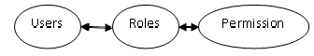
- Develop the two way acess security API
  - API Call - Authenticate User. Authenticaion API uses the below services interms:
      - Attribute Validation
      - Role Validation
  - API Call – Aceess Resoucrces available in the Cloud
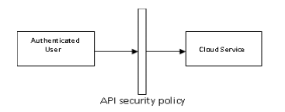

Authenticate User:
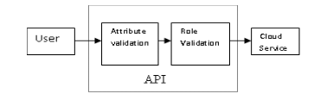
Attribute Validation -
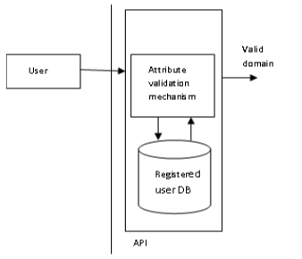
Role Validation -

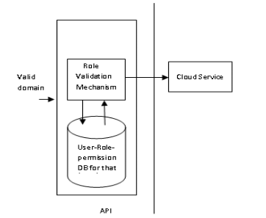
6. Create On-Demand provisioning system which grants access for certain time with option to extend the session via UI once the allocated time finishes privilege revoked automatically. UI based system, provides required access for certain time interval.

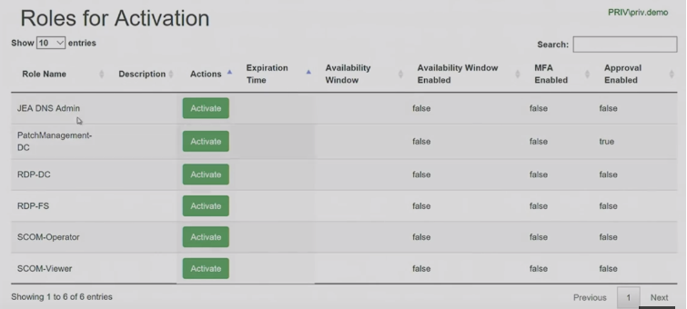

    - Develop Tesorflow based Deeplearning Classification System with Multi variable Dataset (Labels Like: Admin, End User, Attack or Misc)
    - Develope Threat Handling system: Alert the Authorised organization role. Implements the order received from Authorised user or Self decision making in critical sitatuion. (i.e, Block the user ID, IP, Domain or Bring down the Affected system to prevent spreading the attack over rest of the systems)

